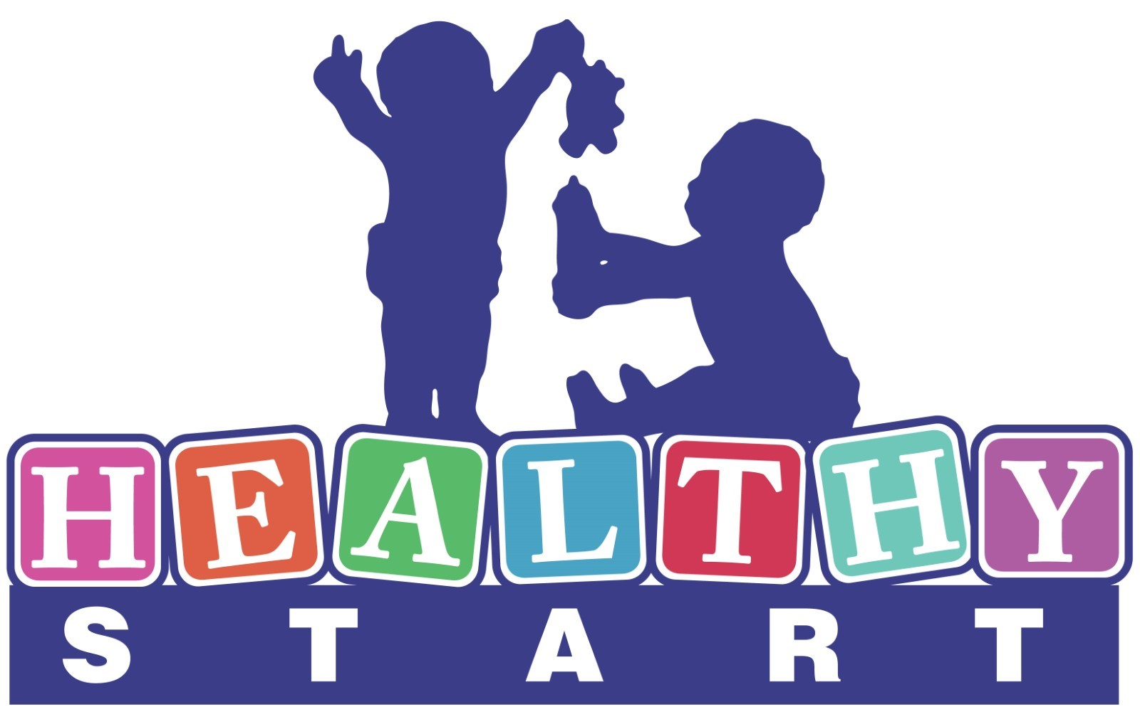 | Family Coach  HELLO BABY PRIORITY  December 2023

The mission of Healthy Start is to improve maternal and child health and to reduce poor birth
outcomes and infant mortality in Allegheny County.

Hello Baby is a voluntary program for parents of new babies in Allegheny County. The program is designed to strengthen families, improve children’s outcomes, and maximize child and family well-being, safety and security. As part of the Hello Baby tiered support strategy, the Hello Baby Priority program focuses on engagement and support for families with highest need.

Overview:
This is a community-based home visiting position contributing to the successful delivery of services and supports for families of newborns in Allegheny County who have complex needs. As a member of the Hello Baby team at Healthy Start, the Family Coach will exhibit expertise in high quality service offerings and will focus on connecting families to services and ongoing follow up with providers through care management (screening, assessment, goal planning, referral and follow up) to enrolled families using the Camden Coalition COACH model. The successful Family Coach is passionate, knowledgeable of family systems, aware of community resources, and has excellent written and verbal communication skills. Case Management and Home Visting experience is required.

The Family Coach is primarily responsible for the following:
- Learning, embracing and promoting the COACH model.
- Employing a strengths-based, “whatever it takes” attitude to serving a population with complex needs; and exploring and embracing the assets of the communities served.
- Ensuring that families have access to necessary services (e.g., housing, home visiting, drug and alcohol, mental health).
- Building and maintaining relationships with other community partners and providers in their specific area of expertise.
- Facilitating care management assessments and working with the family to develop a care plan.
- Supporting care plan goal development and monitoring ongoing progress.
- Documenting participant service delivery based on established guidelines and protocols.
- Maintaining relationships among the Hello Baby team (Healthy Start and DHS), family support centers and other providers and community resources that contribute to the success of enrolled families.
- Participating in individual and team case review, reflective supervision, prescribed trainings and meetings.
- Operates a variety of office equipment, i.e., copier machine, facsimile, etc.
- Performs other job-related duties as assigned by immediate supervisor.

Qualifications of Position:
The Family Coach will have at least 3-5 years of progressively responsible social work or similar experience. Bachelor’s degree or Master’s degree preferred. Significant experience/training in lieu of degree may be considered.

Additional Requirements:
- Act 33/34 and FBI Clearances are required.
- Must possess a valid unrestricted Pennsylvania Driver’s License, have reliable transportation and able to conduct home visits as needed.
- Must possess current and valid unrestricted automobile insurance and be listed as an insured driver.
- Fully vaccinated for COVID-19.

Supervisory Relationship:
This position works under the direction of the Hello Baby Team Supervisor.

Compensation:
The starting salary range for this position is $42,000-$47,000 annually, commensurate with skills and experience. We offer a comprehensive and competitive benefits package.

Reasonable accommodations may be made to enable individuals with disabilities to perform essential functions. Nothing in this job description restricts management’s right to assign or reassign duties and responsibilities to this job at any time.

FLSA Status: Exempt

Application Instructions:
Send resume and cover letter to HR@hsipgh.org

