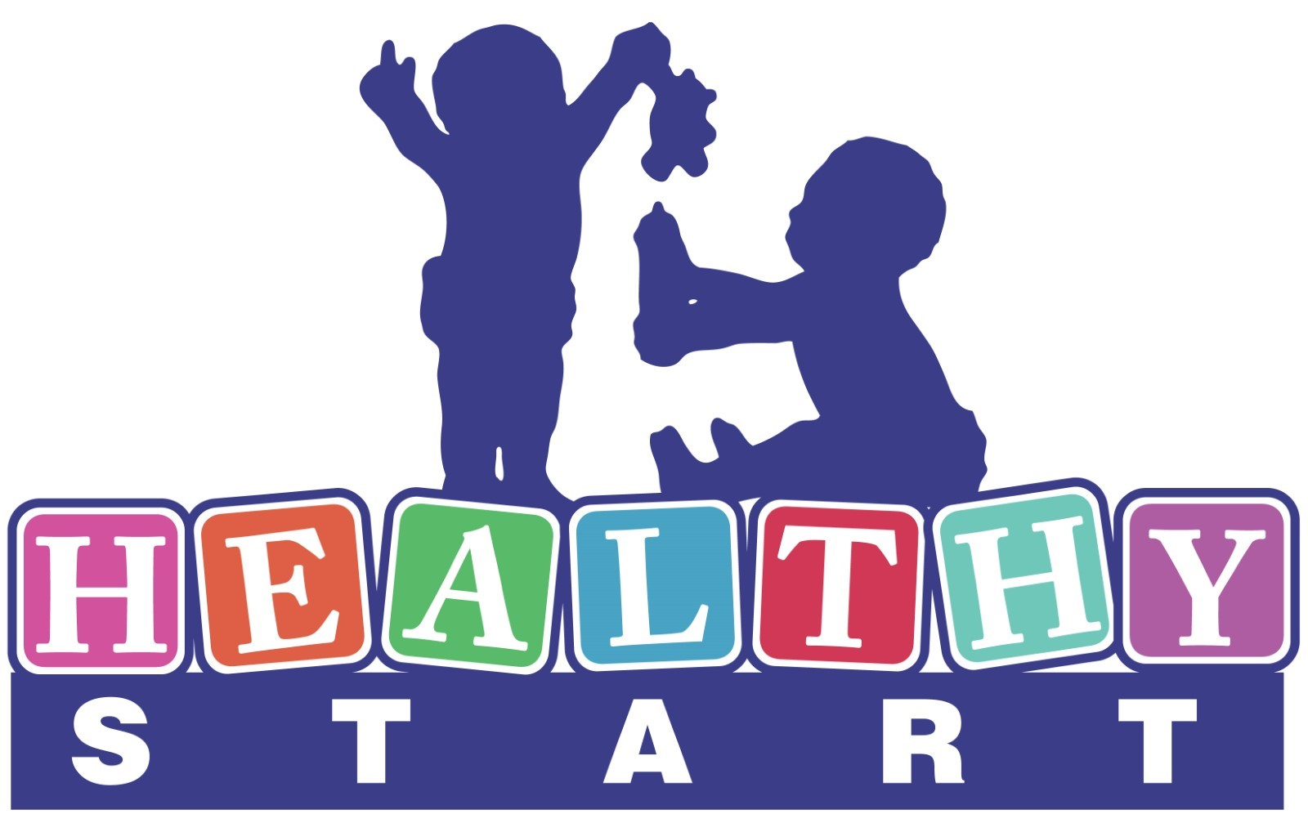 | Outreach & Engagement Specialist  HELLO BABY PRIORITY
The mission of Healthy Start is to improve maternal and child health and to reduce poor birth outcomes and infant mortality in Allegheny County.

Hello Baby is a voluntary program for parents of new babies in Allegheny County. The program is designed to strengthen families, improve children’s outcomes, and maximize child and family well-being, safety and security. As part of the Hello Baby tiered support strategy, the Hello Baby Priority program focuses on engagement and support for families with the highest need.

Position Overview:
This is a community-based home visiting “peer support” position contributing to the successful delivery of services and supports for families of newborns in Allegheny County who have complex needs. As a member of the Hello Baby Priority team, the Outreach & Engagement Specialist (OES) is extremely knowledgeable of their assigned service area and the unique dynamics of family and community within the geographic region. The OES will focus on outreach, engaging and supporting enrolled families using the Camden Coalition COACH model. The successful OES is tenacious, passionate, knowledgeable of family systems, aware of community resources, is empathetic, is flexible and thinks outside the box, has excellent written and verbal communication skills, and embodies the project’s core principles of community engagement, authentic healing relationships, family and child well-being, equity and respect.

Primary responsibilities:
- Learning, embracing, and promoting the COACH model.
- Employing a strengths-based, “whatever it takes” attitude to serving a population with complex needs; and exploring and embracing the assets of the communities served.
- Using referral data to contact and engage families.
- Resolving missing, incorrect, or incomplete contact information.
- Developing and implementing creative, ‘outside the box’ outreach and engagement strategies within the scope of existing program guidelines and protocols.
- Connecting families to basic needs supports and resources.
- Providing support for social workers and activities towards family goals which may include attending appointments, phone calls, home visits, transportation, childcare support and other resources.
- Maintaining relationships among the Hello Baby team (Healthy Start and DHS), family support centers and other providers and community resources that contribute to the success of enrolled families.
- Employing strong organizational skills and maintaining accurate and timely documentation of outreach and engagement attempts and contacts.
- Participating in individual and team case review, supervision, prescribed trainings, and meetings.
- Operates a variety of office equipment, i.e., copier machine, facsimile, etc.
- Performs other job-related duties as assigned by immediate supervisor.

Qualifications of Position:
The OES must demonstrate a connectedness and passion for family and community. The OES will have at least a high school diploma or GED and at least 5 years of progressively responsible work experience with transferable skills. Community-based work and/or substantial related volunteer experience such as Family Development Specialist, home visiting or other family support role preferred.

Additional Requirements:
- Act 33/34 and FBI Clearances are required.
- Must possess a valid unrestricted Pennsylvania Driver’s License, have reliable transportation and able to conduct home visits as needed.
- Must possess current and valid unrestricted automobile insurance and be listed as an insured driver.
- Fully vaccinated for COVID-19.

Supervisory Relationship:
This position works under the direction of the Hello Baby Team Supervisor.

Compensation:
The starting salary for this position is $36,000 - $38,000 annually, commensurate with skills and experience. We offer a comprehensive and competitive benefits package.

Reasonable accommodations may be made to enable individuals with disabilities to perform essential functions. Nothing in this job description restricts management’s right to assign or reassign duties and responsibilities to this job at any time.

FLSA Status: Exempt

Application Instructions:
Send resume and cover letter to HR@hsipgh.org

